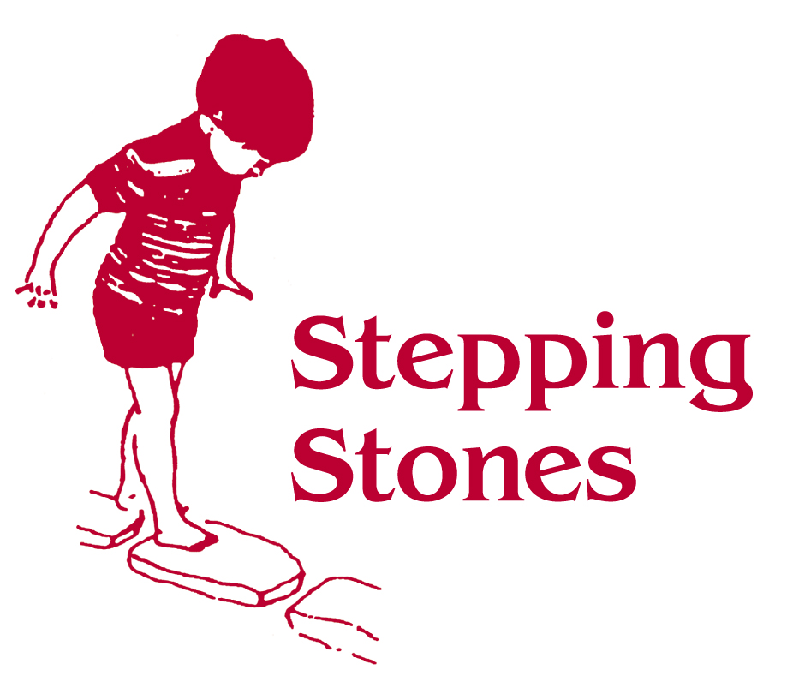
Procedure for unwell children and infectious diseases

- Stepping Stones adheres to the guidance on infection control in school and other childcare settings set by the Health Protection Agency.

- Children should not be sent to Stepping Stones if they are unwell and not less than 48 hours after being sick or having diarrhea.

- Parents/Care givers should inform Stepping Stones by
Email admin@steppingstonestrowbridge.co.uk
Telephone 01225 350015
Text/phone 07957826722 if their child is unwell and will be absent.

- Our policy for the exclusion of ill or infectious children is discussed with parents and we will follow the procedure for contacting parents or other authorised adults if a child becomes unwell while in our setting.

- Stepping Stones will only provide care for children who become unwell whilst in the setting, (develop a temperature or an infectious condition) until parent/care givers or another authorized adult can collect the child from our setting.

- Parents are notified when required if an infectious disease such as Chicken pox has been reported which may affect their child in session.

- Children with head lice are not excluded but recommendations will be made to parent/carers that the condition must be treated along with all members of the household to remedy the condition and restrict spread.

- Good hygiene practice to reduce the spread of infection will be carried out at all times.

- Stepping Stones will plan for any known specific or medical conditions that may affect children or families attending the setting. Children or families will not be excluded because of these. Stepping Stones will identify appropriate procedures to support safety and reduce any risk of cross infection in accordance with Health Protection Agency guidance.

- Ofsted will be notified of any infectious diseases deemed notifiable in accordance with Health Protection Guidance by a qualified medical professional.

