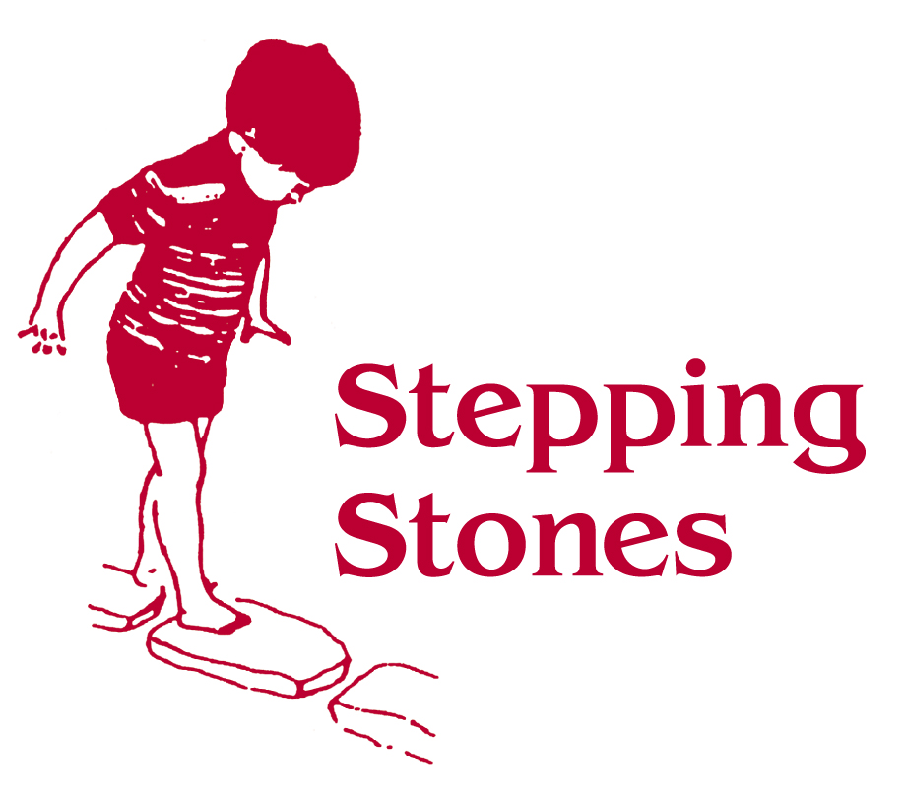

Positive Behaviour Policy

Adults caring for children in Stepping Stones are able to manage a wide range of children’s behaviour in a way which promotes their welfare and development.
Individual children within the setting may have personalised behaviour programmes agreed with parents/carer’s. Stepping Stones will support all children including those displaying personal social, emotional difficulties.

We maintain that all behaviour is a form of communication. By understanding this all children shall have their individual needs met and the opportunity to reach their full potential.

Our Aim is for children attending Stepping Stones to be

- Safe
- Secure
- Respected
- Praised

Our Policy is for adults to be aware of
- The child’s developmental profile
- Their own and the child’s safety
- Agreed appropriate physical contact with the children
- The rules and boundaries
- Working as a team - consistently
- Giving children the confidence to manage their behaviour in a appropriate manner

Action
- To always aim for positive behaviour and actions
- To decide on rules and boundaries and inform all concerned
To agree who will be the lead adult and inform all concerned
- To gain child’s attention
- To keep language clear and simple with appropriate tone
- To use appropriate tools eg objects of reference/visual strategies.
- To give enough time for the child to respond
- To use distractions and appropriate acceptable activities.
- To praise all good behaviour with words and rewards

Who is responsible
- Setting Manager, Playroom Manager, Deputy Playroom Manager, Senior SEND Early Years Practitioners, SEND Early Years Practitioners to agree a group strategy.

PARENTS WILL BE KEPT INFORMED AT ALL TIMES OF ANY CHANGES OF CHILDREN’S BEHAVIOUR OR METHODS USED TO SUPPORT THEM.

