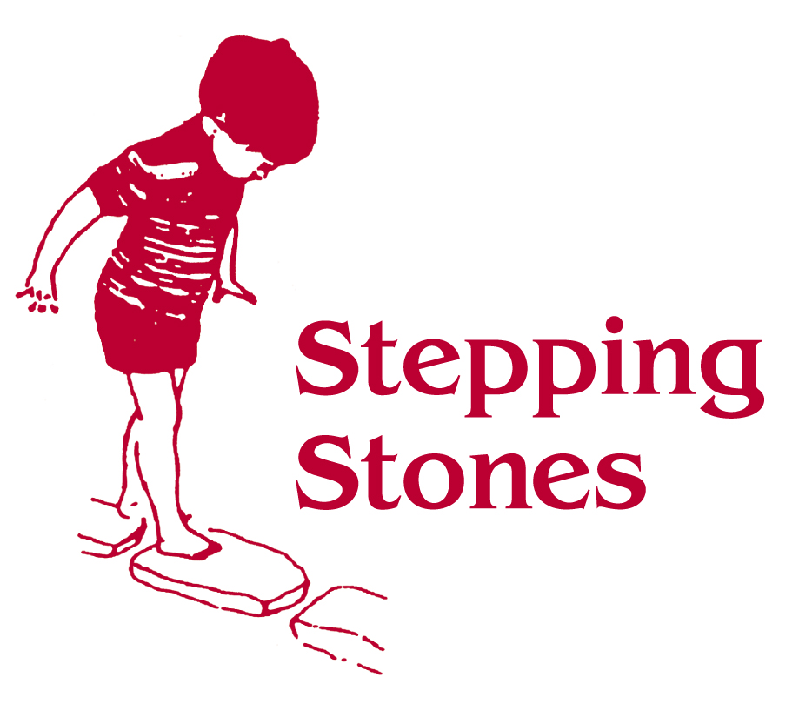
COMPLAINTS PROCEDURE
(Reviewed September 2024)

Stepping Stones welcomes comments and discussions regarding our practice. The first step would always be to raise any concerns you may have with us, and we would hope that most issues can be resolved in this way.

In the event that you wish to make a complaint our Complaints Procedure works as follows.

- If anyone has a complaint of any sort regarding Stepping Stones they should first raise the matter with Debbie Wickham, Manager at Stepping Stones, either verbally or in writing, who will endeavor to resolve the complaint. The matter will be reported to Tracey-Leigh Meadowcroft, Chair of the Management Committee.

- If the complaint is not settled by the actions of the Manager, the complainant should communicate directly with the Chair of the Committee, either verbally or in writing, who will report the matter to the Management Committee.
A complaint can be made directly to Tracey-Leigh Meadowcroft, Chair of the Management Committee 07540067311.

- If the complaint is not settled by the action of the Chair of the Committee, then it will be brought to the full management committee of the group.

- Should the matter remain unresolved after 28 days, an independent arbitrator may be agreed to by the parties, and their decision will be taken as binding to both parties.

- The Independent Arbitrator will be asked to report on their decision within 10 working days of that meeting.

- We undertake that our services to any child will not be withdrawn or adversely affected as a result of any complaint.

- If the complaint is about Stepping Stones as a whole and the matter is unresolved you can contact Ofsted. Ofsted states that complainants must have followed the Stepping Stones complaints procedure before making a complaint to Ofsted.
Ofsted states that it cannot:
- consider issues about individual pupils.
- investigate specific incidents.
- judge how well an early years setting responded to a complaint.
- mediate or resolve disputes between you and the early years setting.

- OFSTED can be contacted directly via
Tel: 0300 123 4666
E mail: enquiries@ofsted.gov.uk
Website: www.ofsted.gov.uk/parents

