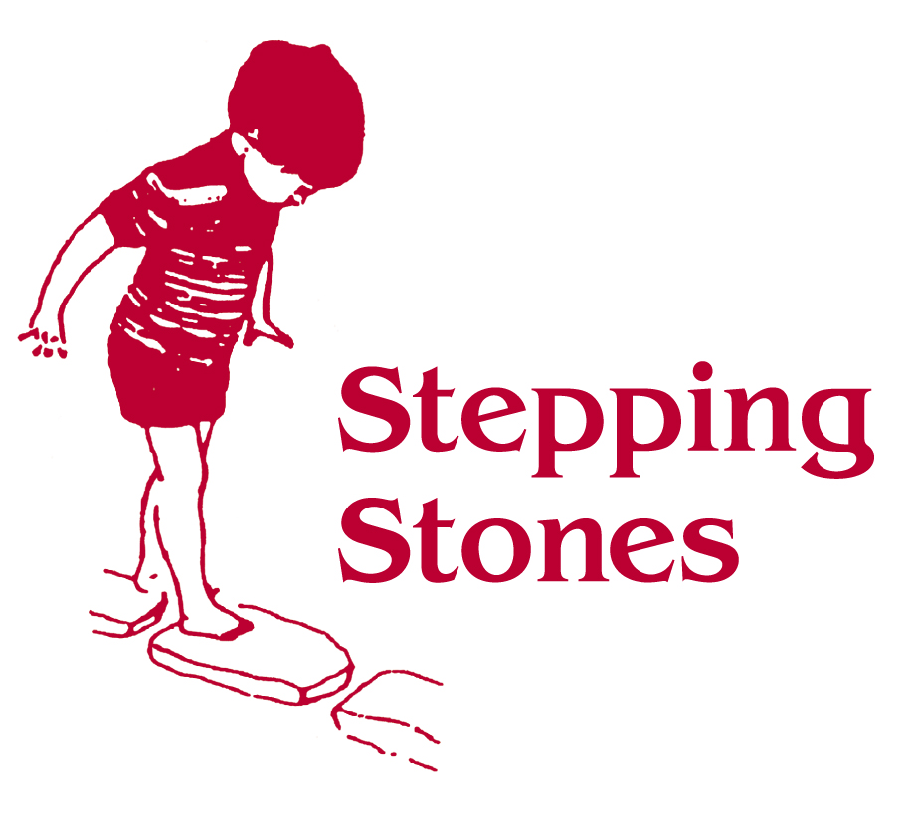
Nappy Changing Policy

Nappies are changed whenever they need changing, using the changing area provided within the children’s toilet facilities.

Children will be shown visual strategies to support their awareness of the nappy change routine, i.e. The object of reference, Makaton, Symbols.

Parents are asked to provide nappies and wipes for their child, but nappy sacks are provided by the setting.

- Staff must wear a disposable apron and disposable gloves while changing wet or soiled nappies. To prevent the spread of infection gloves and apron should be used once.

- To comply with our lifting and moving policy and to support the safety and comfort of children the changing mat may be brought down to the floor to enable staff to change a child’s nappy ensuring safety for both the staff member and child.

- Nappy creams will only be used where provided by parents and with signed parental permission only.

- Wet and soiled nappies should be placed into a nappy sack, (double wrapped if nappy badly soiled) and disposed of in the hygienic disposal unit provided.

- The changing mat, surrounding area, and nappy disposal bin should be cleaned/wiped with anti bacterial spray/wipes between every change to reduce any risk of possible infection being spread.

- Dispose of disposable gloves and apron before washing hands or returning to the playroom.

- Hand washing facilities and/or Hand wipes are available for staff and children (as appropriate) to clean their hands thoroughly after nappy changing. (Hands must be cleaned even if gloves are worn).

- Paper towels are provided for hand drying to reduce the risk of cross contamination or spread of germs or infection.

- Changing mat and surrounding area are left clean, tidy and stock replenished as required throughout each day

- All nappy changes are recorded and initialled on a daily basis.

Access for Parent/Carers to the toilet/nappy change area is only permissible when a team member has first checked that the area is unoccupied and supervised/advised on use of facilities.

Toilet training and Potty Policy

At Stepping Stones we aim to support each child to develop awareness of and independence in skills relating to meeting their toileting needs. This support will be differentiated as required to meet each individual child’s developmental needs.
As far as possible toilet training strategies initiated at home will be continued within sessions to maintain continuity.

- Children will be shown visual strategies to support meeting their independent toileting needs, i.e. Objects of reference, Makaton, Symbols

- Children will be offered the opportunity to go to the toilet or potty at intervals or if the child indicates his or her toileting needs. All soiled or wet clothing and skincare regime will be as in nappy changing policy.

- Soiled clothing should be bagged and returned to parents

- Parents will be kept informed of their child’s progress at the end of session by an appropriate staff member.

- When supporting children using a potty staff should wear disposable gloves and apron.

- When a child has used a potty its contents should be flushed down the toilet bowl avoiding splashing.

- Rinse as required with cold water to remove anything left and empty down the toilet as before.
- Wash the potty using anti bacterial spray or wipes and allow to air dry.

- Check the toilet seat/floor area to remove any possible spillages. Spray with antibacterial spray.

- Remove gloves and apron and dispose of in nappy bin

- Hand washing facilities and/or Hand wipes are available for staff and children (as appropriate) to clean their hands thoroughly after toileting. (Hands must be cleaned even if gloves are worn).

- All Toileting events are recorded and initialled on a daily basis.

Access for Parent/Carers to the toilet/nappy change area is only permissible when a team member has first checked that the area is unoccupied and supervised/advised on use of facilities. Following each visit the area will be checked and cleaned by a member of staff immediately after the child and parent have left the area.

