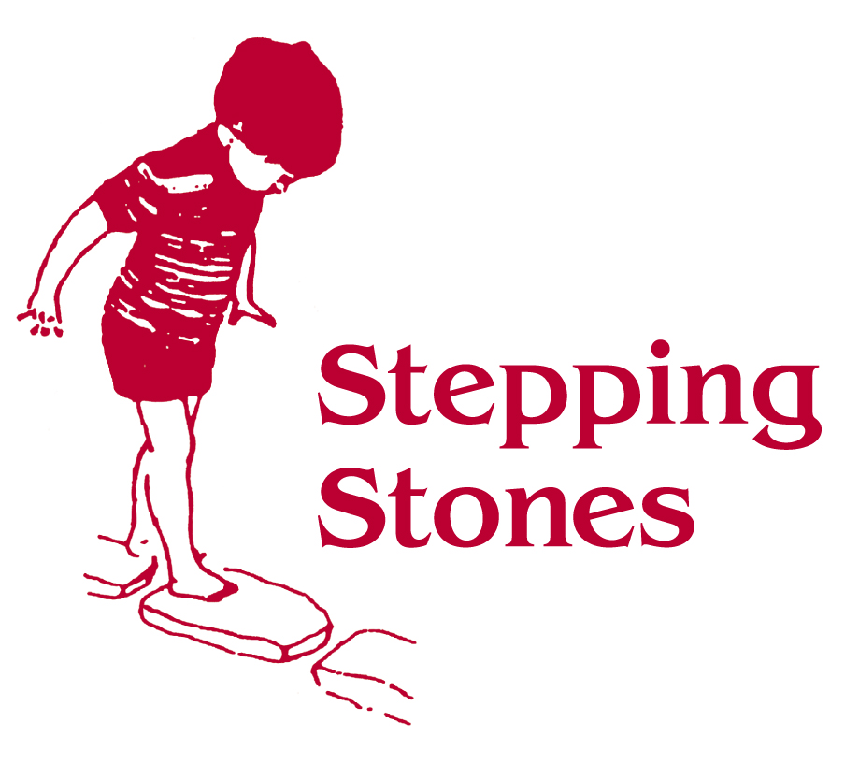
The Manual Handling Operations Regulations 1992 require employees to
- Use the “safe systems” of work (moving and handling procedures put into place by the employer).
- The term “manual handling” is used to denote any jobs or tasks where human effort is needed to move an object or child including lifting, lowering, pushing and pulling etc

Adults are provided with guidance about the safe storage, movement and lifting and erection of large pieces of equipment.

When adults need to be reach up to check or store equipment they are provided with safe equipment to do so.

Employees have a responsibility not to undertake any manual handling activities that may cause harm to themselves or others and must adhere to the information, instructions and training provided

Lifting/moving children
To ensure the safety and care needs of each child are met:

- All adults should ongoingly assess each child’s physical and developmental needs.

- Where required the Keyworkers and relevant therapists will record the need for specialist interventions/equipment in the child’s file.

- Manual Handling Assessments will be reviewed whenever there is cause to suspect that they are no longer valid as children grow or their needs change.

Guidelines for lifting
Always Risk Assess:-

Think why you are moving a child

Think where you are moving a child to

Think how you are going to move a child.

Think do you need help

Think are you safe

Think is the child safe

This also applies to lifting equipment.

Remember you are important do not injure yourself. Once trained it is expected that all employees will follow the correct techniques for all manual handling activities.

Risk Assessments and Managing Safety

Outdoor and Indoor spaces, furniture, equipment, toys and resources must be safe and suitable for their purpose. In order to ensure the safety of both children and adults, Stepping Stones will ensure that:

- Appropriate employee and public liability insurance is in place.
- Training will be provided to ensure best practice in Health and Safety in our workplace.
- All children with be supervised by adults at all times. Appropriate adult:child ratios will be in place.
- Risk assessments of the premises, environment and equipment will be carried out and reviewed on a regular basis.
- Daily safety checks and risk assessments are carried out.
- All reasonable steps are taken to ensure that potential hazards to children, staff and visitors are identified, made safe and resolved so that any risk is kept to a minimum.
- The Stepping Stones environment, buildings and outside space will be kept safe and secure. All staff and visitors will be required to sign in and out.
- Children will leave Stepping Stones only with an appropriate adult authorised by parents.
- A lost or uncollected child policy is in place.
- All dangerous materials will be secured and kept out of the reach of children.
- All legal and statutory regulations relating to all aspects of Stepping Stones activities are to be observed at all times. Particular reference must be made to the Health and Safety at work Act 1974 and all the regulations made under it, with any additional codes of practice issued by the Health and Safety Commission which can regulate Stepping Stones functions and activities.
- Stepping Stones has a staff safety policy to ensure the safety of all staff when working alone in the building or as part of a Home or Outreach visit.
- Any significant changes to the Stepping Stones premises will be reported to Ofsted prior to the event or within 14 days. Failure to comply with this is an offence.

Smoking and Vaping

Stepping Stones is well ventilated and smoke free environment. Smoking and Vaping is prohibited on our premises.

This policy links to The Stepping Stones Health and Safety Policy.

